Monday, May 13, 7:00pm
JWP/ Night Town Benefit Concert
for
The 2013 Roberto Ocasio Latin Jazz Music Camp
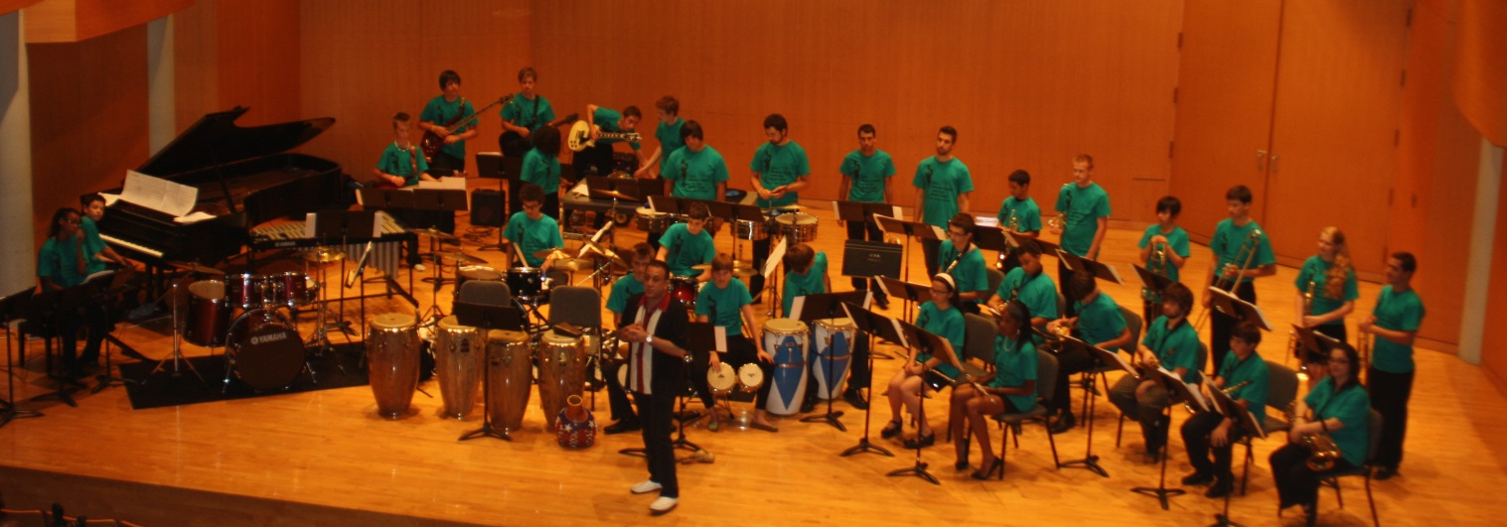
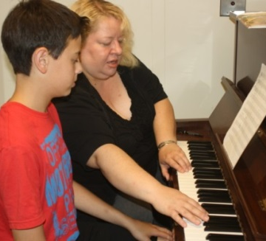
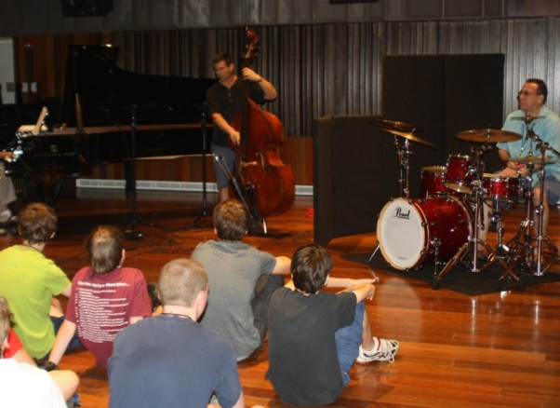
An incredible 90-minute show of energy and imagination with
Bobby Sanabria
7-time Grammy® nominated Afro-Cuban Jazz Drummer/Percussionist/ Band Leader
Jackie Warren, Cleveland’s First Lady of Latin & Jazz Piano
Peter Dominguez, Renowned Oberlin Conservatory Jazz Double Bassist
Brad Wagner, Akron Saxophonist Supreme
In the spirit of
$25 Admission Roberto Ocasio
All proceeds toward scholarships please help support
and student expenses. the next generation of
Night Town 50% student discount off LATIN JAZZ!
ticket price (students under 18
must be accompanied by adult to
receive discount)
Reservations: 216.795.0550
Night Town
12387 Cedar Road
Cleveland Hts., OH 44106
The 9th Annual Roberto Ocasio Latin Jazz Camp
July 7-12 – Cleveland State University
robertoocasiofoundation.org -- 440.572.2048
Students & Parents, enroll at the Concert and receive $100 tuition discount!

